# Introduction

# Methods/ Technologies Used

# Literature Review

# Bacterial Explanations

|  |  |
| --- | --- |
| Name | Description |
| Firmicutes | Firmicutes is the main bacterial phylum, comprising over 250 genera, including Lactobacillus, Streptococcus, Mycoplasma, and Clostridium which are able to produce several short chain fatty acids (SCFAs) like butyrate. (Tissue, 2017) |
| Bacteroides | A genus of gram-negative anaerobic bacteria that belong to the family Bacteroidaceae, that have rounded ends, produce no endospores and no pigment, and that occur usually in the normal intestinal flora. (Merriam-Webster, n.d.) |
| Euryarchaeota | Archaebacteria; Ability to perform cellular respiration using carbon as their electron acceptor and capable of producing methane. Often found in the stomachs of ruminants including cows. (Biology Dictionary, n.d.) |
| Proteobacteria |  |
| Actinobacteria | Actinobacteria constitute one of the largest phyla among Bacteria and represent gram-positive bacteria with a high G+C content in their DNA. This bacterial group includes microorganisms exhibiting a wide spectrum of morphologies, from coccoid to fragmenting hyphal forms, as well as possessing highly variable physiological and metabolic properties. Furthermore, Actinobacteria members have adopted different lifestyles, and can be pathogens (e.g., Corynebacterium, Mycobacterium, Nocardia, Tropheryma, and Propionibacterium), soil inhabitants (Streptomyces), plant commensals (Leifsonia), or gastrointestinal commensals (Bifidobacterium). (Anon., 2007) |
| Verrucomicrobia | The phylum Verrucomicrobia is a divergent phylum within domain Bacteria including members of the microbial communities of soil and fresh and marine waters; recently extremely acidophilic members from hot springs have been found to oxidize methane. (Lee, et al., 2009) |
| TM7 | TM7 is a recently described subgroup of Gram-positive uncultivable bacteria originally found in  natural environmental habitats. An association of the TM7 bacterial division with the inflammatory  pathogenesis of periodontitis has been previously shown. (Kuehbacher, et al., n.d.) |
| Spirochaetales | Spirochete, (order Spirochaetales), also spelled spirochaete, any of a group of spiral-shaped bacteria, some of which are serious pathogens for humans, causing diseases such as syphilis, yaws, Lyme disease, and relapsing fever. Spirochetes are gram-negative, motile, spiral bacteria, from 3 to 500 m (1 m = 0.001 mm) long. (Encyclopædia Britannica, Inc, 2019) |
| Cyanobacteria | Cyanobacteria are aquatic and photosynthetic, that is, they live in the water, and can manufacture their own food. Because they are bacteria, they are quite small and usually unicellular, though they often grow in colonies large enough to see. They have the distinction of being the oldest known fossils, more than 3.5 billion years old. (Berkeley, n.d.) |
| Fibrobacteres | The phylum Fibrobacteres currently comprises one formal genus, Fibrobacter, and two cultured species, Fibrobacter succinogenes and Fibrobacter intestinalis, that are recognised as major bacterial degraders of lignocellulosic material in the herbivore gut. (Ransom-Jones, et al., 2012) |
| SR1 | SR1 includes cosmopolitan bacteria that are found in marine and terrestrial high-temperature environments, fresh-water lakes, and subsurface aquifers. SR1 bacteria also associate with animals and exist in termite and mammalian digestive tracts as well as in the human oral cavity. SR1 is in low abundance in healthy oral microbiota (∼0.1% on average) (Campbell, et al., 2013) |
| Lentisphaerae | the phylum Lentisphaerae comprised the orders Lentisphaerales (Cho et al., 2004) and Victivallales (Cho et al., 2004) and five subphyla that contain no cultured representatives (Hedlund et al., 2011). Lentisphaera accommodates Gram-negative, nonmotile, non-pigmented cocci that produce extracellular polymeric substances in oligotrophic seawater medium. (Choi, et al., 2013) |
| Elusimicrobia | Organisms of the candidate phylum termite group 1 (Elusimicrobia  ) are regularly encountered in termite hindguts but are present also in many other habitats. (DP, et al., 2009) |
| Planctomycetes | Planctomycetes are a unique divergent phylum of the domain Bacteria. Members display a number of unusual properties, such as cell compartmentalization among many species examined electron microscopically, the presence of unusual or unique lipids, such as sterols and ladderane lipids in some species, and unique physiology in some species, such as the anammox planctomycetes performing ammonium oxidation anaerobically. (Kurtböke, 2017) |
| Tenericutes | A phylum of gram-negative bacteria consisting of cells bounded by a plasma membrane. Its organisms differ from other bacteria in that they are devoid of cell walls. This phylum was formerly the class Mollicutes. Mollicutes is now the sole class in the phylum Tenericutes. (U.S. National Library of Medicine, 2011) |
| Synergistetes | Members of the phylum Synergistetes have been demonstrated in several environmental ecosystems and mammalian microflorae by culture-independent methods. In the past few years, the clinical relevance of some uncultivated phylotypes has been demonstrated in endodontic infections, and uncultured Synergistetes have been demonstrated in human mouth, gut and skin microbiota. (H1, et al., 2010) |
| Chloroflexi | The Chloroflexi is one of the most common and diverse bacterial phyla in sponges and contains many sponge-specific lineages. (Schmitt, et al., 2011) |
| Fusobacteria | Fusobacteria are non–spore-forming, nonmotile, pleomorphic, gram-negative, obligate anaerobic bacilli that can cause a wide spectrum of human disease ranging from mild pharyngitis to sepsis, and these organisms are most notorious for causing septic thrombophlebitis of the internal jugular vein, commonly referred to as Lemierre syndrome.1 (Rellosa & Vodzak, 2018) |
| Acidobacteria | Acidobacteria is a very abundant and ubiquitous bacterial phylum in natural ecosystems. The dominance of Acidobacteria in acidic environments and chemically polluted sites (e.g. where heavy metal5,6,7, petroleum compounds8, linear alkylbenzene sulfonate9 and p-nitrophenol10 are major contaminants) is related to the ability of these bacteria to produce large amounts of EPS. (Kielak, et al., 2017) |
| Chlamydiae | Chlamydiae are obligate intracellular bacteria. They lack several metabolic and biosynthetic pathways and depend on the host cell for intermediates, including ATP. Chlamydiae exist as two stages: (1) infectious particles called elementary bodies and (2) intracytoplasmic, reproductive forms called reticulate bodies. The chlamydiae consist of three species, C trachomatis, C psittaci, and C pneumoniae. (Becker, 1996) |

# Exploratory Data Analysis

|  |  |
| --- | --- |
| Sampling Round | Occurance |
| R1 | Prior to 1st injection |
| R2 | After 3rd of 3 injections |
| R3 | 2 Weeks after R2 |

To examine the changes in Microbial Abundance over time a series of boxplots and other visualisations have been created to convey changes in the data.

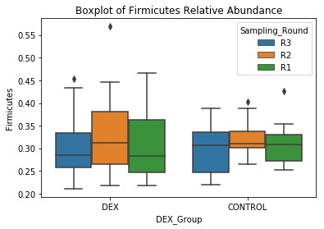

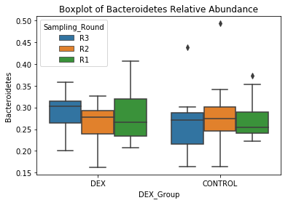

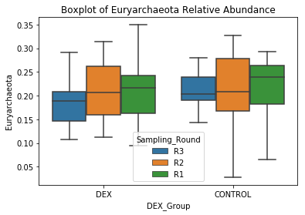

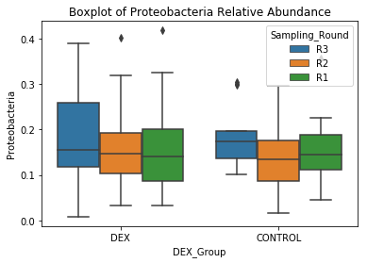

# Bibliography

Anon., 2007. Genomics of Actinobacteria: Tracing the Evolutionary History of an Ancient Phylum. *Microbiol & Molecular Biology Reviews,* 71(3), pp. 495-548.

Becker, Y., 1996. Chapter 39 Chlamydia. In: S. Baron, ed. *Medical Microbiology.* Galveston: University of Texas Medical Branch at Galveston; .

Berkeley, n.d. *Introduction to the Cyanobacteria.* [Online]   
Available at: https://ucmp.berkeley.edu/bacteria/cyanointro.html

Biology Dictionary, n.d. *Archaebacteria.* [Online]   
Available at: https://biologydictionary.net/archaebacteria/

Campbell, J. et al., 2013. UGA is an additional glycine codon in uncultured SR1 bacteria from the human microbiota. *Procededings of the National Academy of Sciences,* 110(14), pp. 5540-5545.

Choi, A., Yang, S.-J., Rhee, K.-H. & Cho, J.-C., 2013. Lentisphaera marina sp. nov., and emended description of the genus Lentisphaera. *International Journal of Systematic and Evolutionary Microbiology,* Issue 63, p. 1540–1544.

DP, H. et al., 2009. Genomic analysis of "Elusimicrobium minutum," the first cultivated representative of the phylum "Elusimicrobia" (formerly termite group 1).. *Applied and Envrionmental Microbiology,* 75(9), pp. 2841-2849.

Encyclopædia Britannica, Inc, 2019. *Spirochete.* [Online]   
Available at: https://www.britannica.com/science/spirochete

H1, M. et al., 2010. Phylogeny, diversity and host specialization in the phylum Synergistetes with emphasis on strains and clones of human origin.. *Research in Microbiology,* 2(161), pp. 91-100.

Kielak, A. et al., 2017. Characterization of novel Acidobacteria exopolysaccharides with potential industrial and ecological applications. *Scientific Reports,* Volume 7.

Kuehbacher, T., Rehman, A. & L, n.d.

Kurtböke, I., 2017. *Microbial Resources: From Functional Existence in Nature to Application.* 1 ed. s.l.:Academic Press.

Lee, K.-C.et al., 2009. Phylum Verrucomicrobia representatives share a compartmentalized cell plan with members of bacterial phylum Planctomycetes. *BioMed Central,* 9(5).

Merriam-Webster, n.d. *bacteroides.* [Online]   
Available at: https://www.merriam-webster.com/medical/bacteroides

Ransom-Jones, E., Jones, D., McCarthy, A. & McDonald, J., 2012. The Fibrobacteres: An Important Phylum of Cellulose-Degrading Bacteria. *Microbial Ecology,* 63(2), pp. 267-281.

Rellosa, N. & Vodzak, J., 2018. *Principles and Practice of Pediatric Infectious Diseases (Fifth Edition).* 1 ed. s.l.:Elsevier.

Schmitt, S. et al., 2011. hloroflexi bacteria are more diverse, abundant, and similar in high than in low microbial abundance sponges. *Federation of European Microbiological Societies,* 78(3), pp. 497-510.

Tissue, G., 2017. *Science Direct.* [Online]   
Available at: https://www.sciencedirect.com/topics/medicine-and-dentistry/firmicutes

U.S. National Library of Medicine, 2011. *Tenericutes.* [Online]   
Available at: https://www.ncbi.nlm.nih.gov/mesh?term=Tenericutes